**ERP ID: 2300032740 NAME: Y.TEJA SAI RAM PRAKASH**

**Verification of Ohms Law**

**Aim:**

To Verify Ohms Law for a given circuit.

**Software required:**

tinkercad

**PROCEDURE:**

1. Login to Tinkercad website through your mail ID and choose the circuit option by clicking on new button.



1. In the search option find the required components like potentiometer, battery, multimeter, bulb, etc.

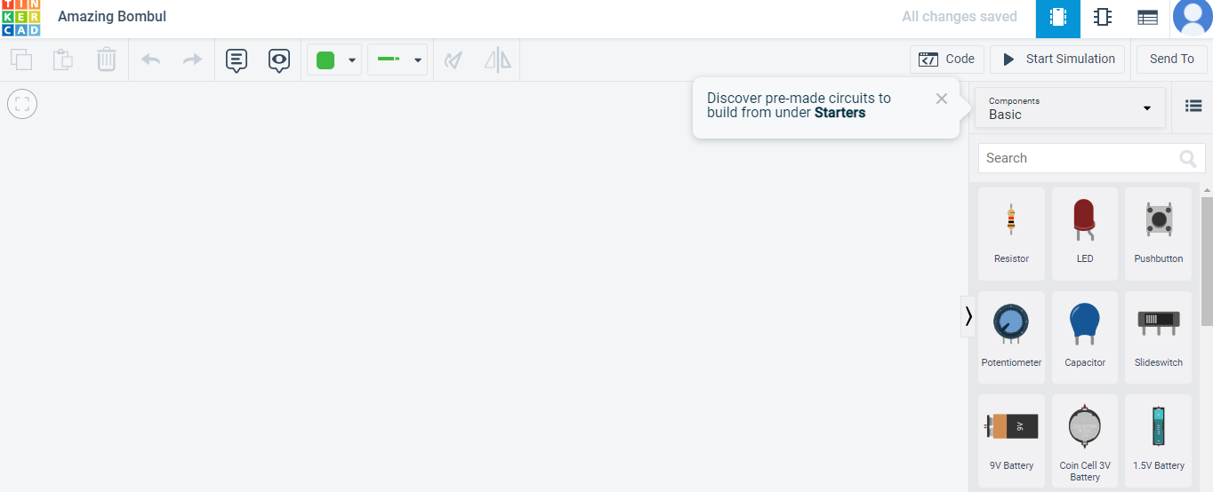

1. Create a loop by connecting the battery and bulb with resistor and 2 multimeters.
2. Fix the resistance as 2500 Ω and record the reading of voltage and current in two multimeters.
3. Recordings show that for a fixed resistance, voltage varies directly with the current. This verifies the Ohm’s law i.e. V = I.R.

**TABULATION:**

|  |  |  |
| --- | --- | --- |
| **Resistor** | **Voltage in Bulb** | **Current** |
| 300Ω | 1.24v | 25.8mA |
| 1000Ω | 412mv | 8.58mA |
| 2000Ω | 211mv | 4.39mA |
| 3000Ω | 142mv | 2.95mA |

**RESULT:**

Thus the basics of ohms law is studied and verified .

